Which of the following statements about starch and glycogen is FALSE?

|  |  |  |
| --- | --- | --- |
|  |  | Both are homopolymers of D-glucose predominantly linked α1-4. |
|  |  | Both have a helical secondary structure. |
| http://owl.cengage.com/owlimages/check.GIF |  | Both serve as structural elements of cell walls, starch in plants, and glycogen in muscle. |
|  |  | Amylose is unbranched; amylopectin and glycogen contain α1-6 branches. |

In the following diagram which pair of sugars are anomers?  
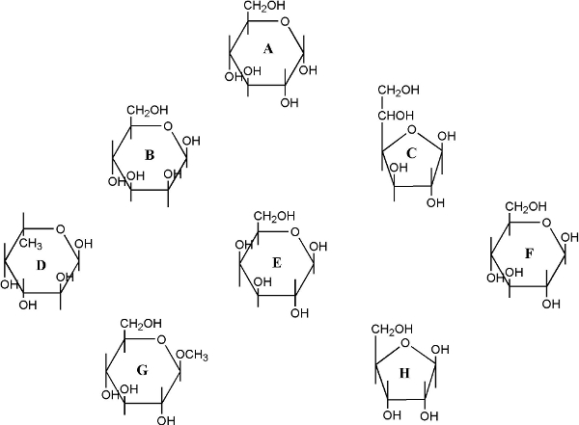

|  |  |  |
| --- | --- | --- |
|  |  | D & G |
| http://owl.cengage.com/owlimages/check.GIF |  | A & F |
|  |  | C & D |
|  |  | A & B |

Choose the correct answer.

|  |  |  |
| --- | --- | --- |
|  |  | lactose is Glcα1-4Glc |
|  |  | sucrose is Glcα1-2Glc |
| http://owl.cengage.com/owlimages/check.GIF |  | maltose is Glcα1-4Glc |
|  |  | cellobiose is Galβ1-4Glc |

Chitin is the earth's second most abundant carbohydrate polymer. Its repeating monosaccharide is:

|  |  |  |
| --- | --- | --- |
|  |  | D-glucose linked β1-4 |
|  |  | L-guluronic acid linked α1-4 |
|  |  | D-manuronic acid linked β1-4 |
| http://owl.cengage.com/owlimages/check.GIF |  | N-acetyl-D-glucosamine linked β1-4 |

Lactose is:

|  |  |  |
| --- | --- | --- |
|  |  | glucose-α-1,2-fructose (Glcα1-2Frc) |
|  |  | glucose-β-1,4-galactose (Glcβ1-4Gal) |
| http://owl.cengage.com/owlimages/check.GIF |  | galactose-β-1,4-glucose (Galβ1-4Glc) |
|  |  | glucose-β-1,4-glucose (Glcβ1-4Glc) |

Amylopectin, a component of starch, and glycogen have similar structures involving α1-4 glycosidic linkages between sugars. The major difference is:

|  |  |  |
| --- | --- | --- |
| http://owl.cengage.com/owlimages/check.GIF |  | Glycogen has more α1-6 branches than amylopectin |
|  |  | Amylopectin has more α1-6 branches than glycogen |
|  |  | Glycogen is water soluble while amylopectin is not |
|  |  | Amylopectin is a galactose polymer while glycogen is a glucose polymer |

The structure of cellulose has the following features:  
a. a linear polymer of D-glucosamine  
b. glycosidic link α1-4.  
c. glycosidic link β1-4  
d. helical structure stabilized by intra-chain H-bonds  
e. linear structure of parallel chains stabilized by intra- and inter-chain H-bonds.  
  
Choose the correct answer

|  |  |  |
| --- | --- | --- |
|  |  | b, d |
|  |  | b, e |
|  |  | a, c, e |
| http://owl.cengage.com/owlimages/check.GIF |  | c, e |